This is already answered which uses extracted zip data but it consumes more memory than simple zip file.

Comparison of zip file and extracted data.

jdk-6u25-fcs-bin-b04-apidocs.zip ---> ~57 MB

after extracting this zip file ---> ~264 MB !

So this approach saves my approx. 200 MB.

**How to use apidocs.zip?**

1.Open Windows -> Preferences

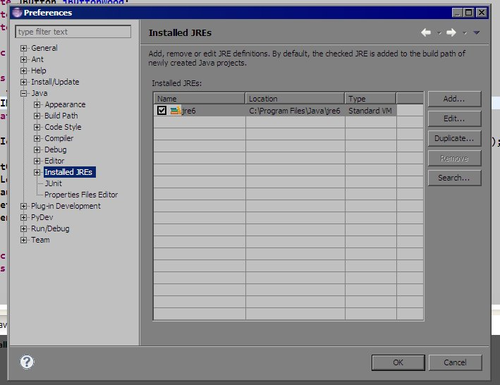

2.Select jre from Installed JREs then Click Edit...

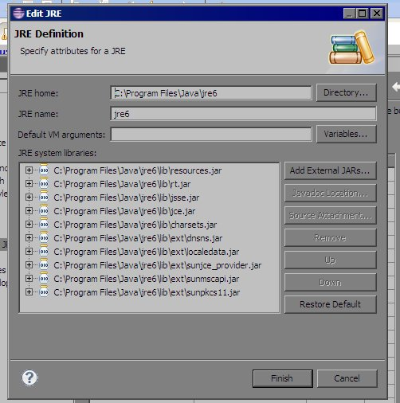

3.Select all .jar files from JRE system libraries then Click Javadoc Location...

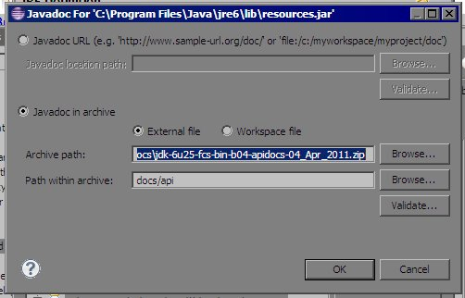

4.Browse for apidocs.zip file for Archive path and set Path within archive as shown above. That's it.

5.Put cursor on any class name or method name and hit Shift + F2